Lab Experiment 4.3 — Zero-shot, One-shot, Few-shot Prompting (AI Assisted Python Programming)
Name: Suvikhyath Thirunahari
Roll No: 2503B05202
Course: AI Assisted Problem Solving Using Python
Date: 06/11/2025

Objective
The objective of this experiment is to understand how different prompting techniques (Zero‑shot, One‑shot, Few‑shot) influence AI‑generated Python code. We use prompting to generate functions, test them, and compare results.

Task 1: Zero-Shot Prompt — Leap Year Checker

Prompt Used:
Prompt used: 'Write a Python function named is_leap_year(year) that returns True if the year is a leap year and False otherwise.'

AI Generated Code:
def is_leap_year(year: int) -> bool:
return (year % 4 == 0) and (year % 100 != 0 or year % 400 == 0)
print(is_leap_year(2000)) # True
print(is_leap_year(1900)) # False
Screenshots:
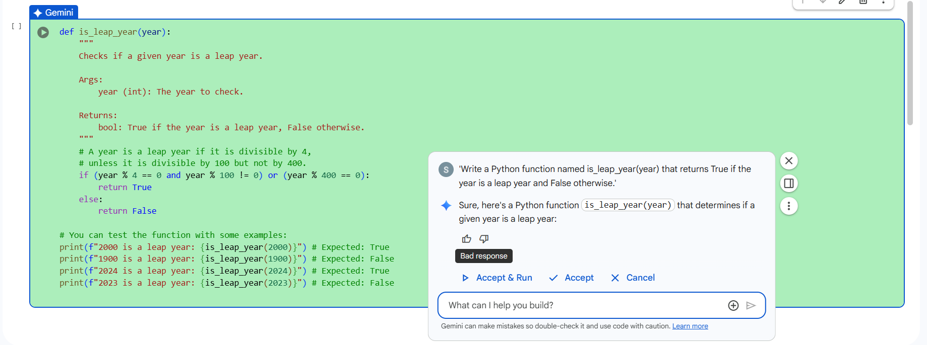
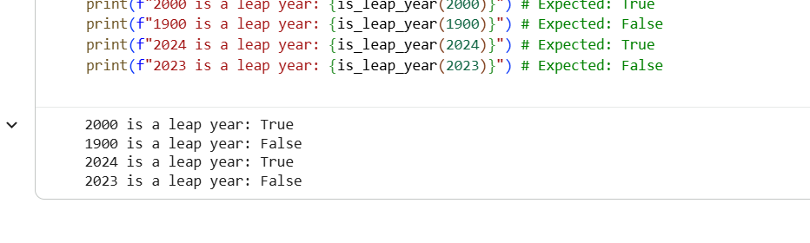
Task 2: One-Shot Prompt — Convert cm to inches

Prompt Used:
Prompt used: 'Function to convert centimeters to inches. Example: input 10 -> output 3.937'.

AI Generated Code:
def cm_to_inches(cm: float) -> float:
return cm / 2.54
print(cm_to_inches(50)) # ~19.685
Screenshots:
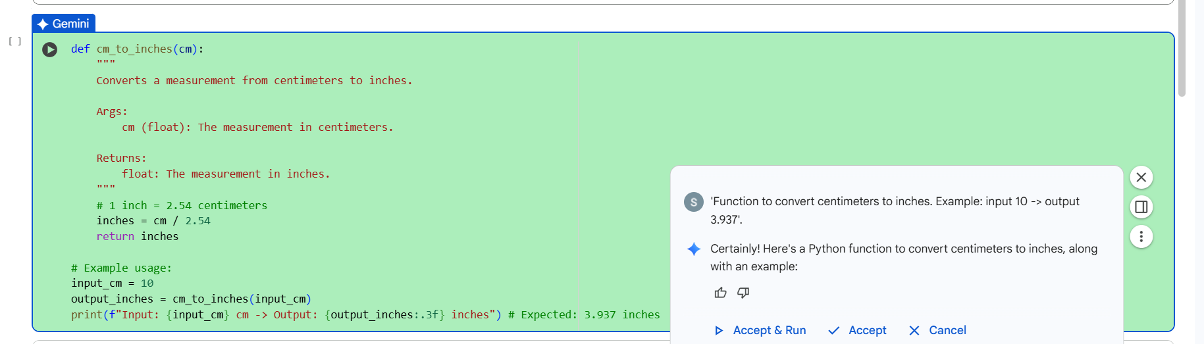
Example:
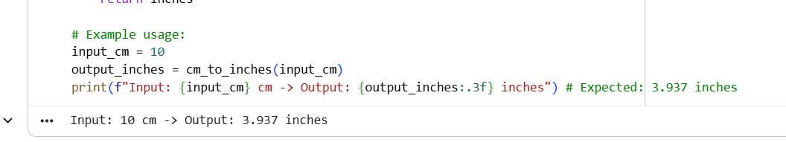

Task 3: Few‑Shot Prompt — Format a Name

Prompt Used:
Prompt used: 'Convert full name into Last, First format. Examples: John Smith → Smith, John; Marie Curie → Curie, Marie'.

AI Generated Code:
def format_name(full_name: str) -> str:
parts = full_name.strip().split()
last = parts[-1]
first = " ".join(parts[:-1])
return f"{last}, {first}"
print(format_name("John Smith"))
print(format_name("Marie Skłodowska Curie"))
Screenshots:
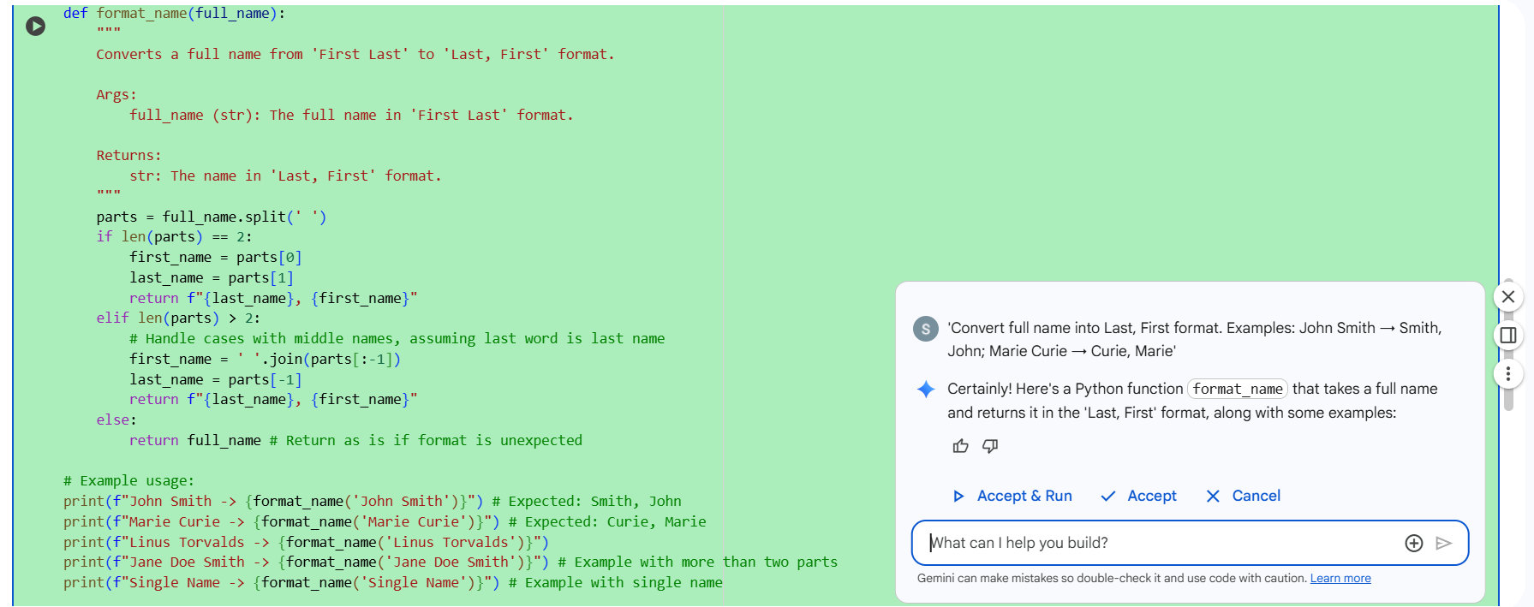
Example:
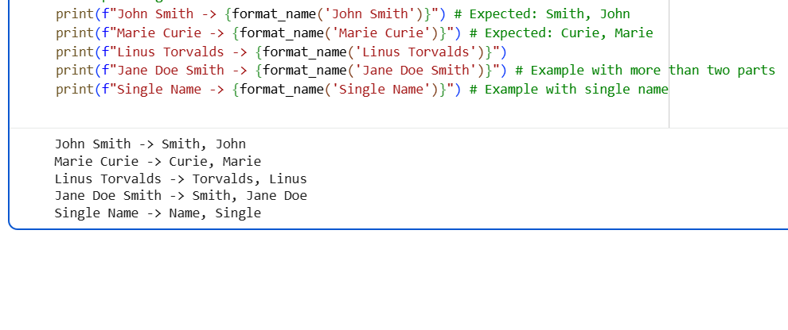

Task 4: Zero-shot vs Few-shot Comparison — Count vowels

Prompt Used:
Prompt used: 'Write a function count_vowels(s) that returns the number of vowels in a string.'
Few-shot examples: 'abc'→1, 'AEIOU'→5, 'Why?'→0

AI Generated Code:
def count_vowels(s: str) -> int:
vowels = set('aeiouAEIOU')
return sum(1 for ch in s if ch in vowels)
print(count_vowels("Hello World")) # 3
Screenshots:
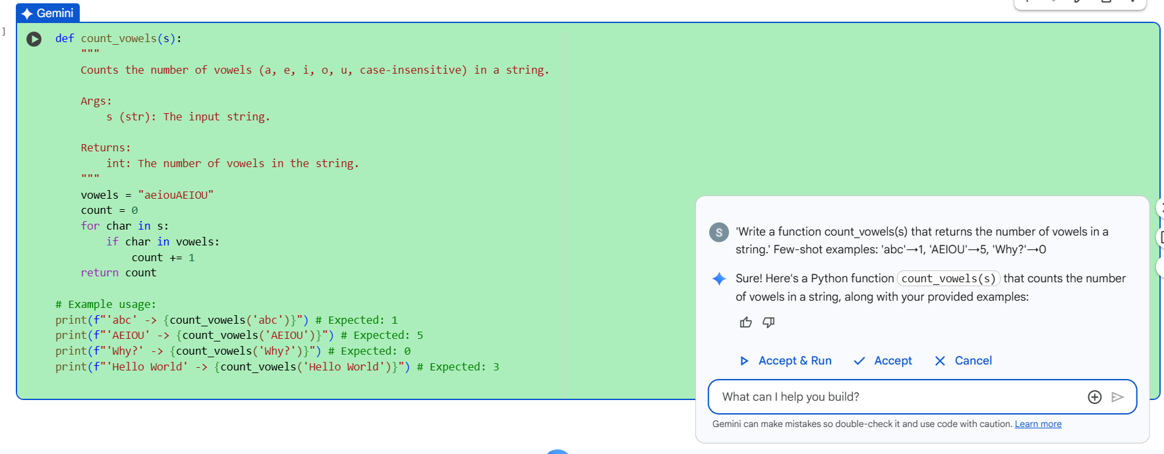
Example:
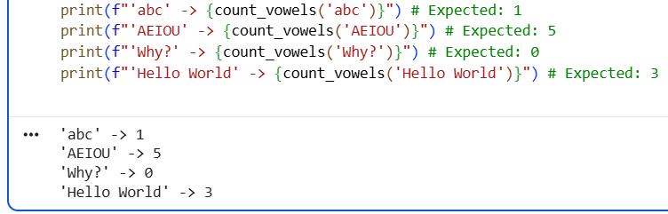

Task 5: Few‑Shot Prompt — Count number of lines in a file

Prompt Used:
Prompt used: 'Write a function that reads a text file and returns number of lines. If file not found, return 0'.

AI Generated Code:
def count_lines(filename: str) -> int:
try:
with open(filename, 'r', encoding='utf-8') as f:
return sum(1 for _ in f)
except FileNotFoundError:
return 0
with open('test_lines.txt', 'w', encoding='utf-8') as f:
f.write("Line1\nLine2\nLine3\n")
print(count_lines('test_lines.txt')) # Output should be 3
Screenshots:
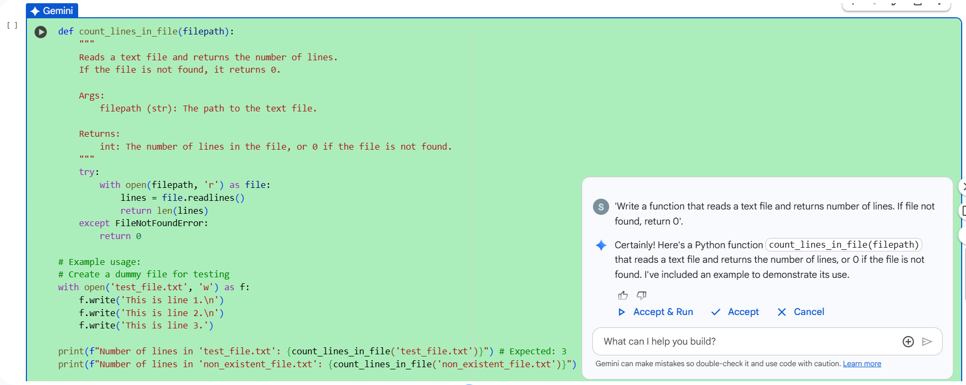
Example:
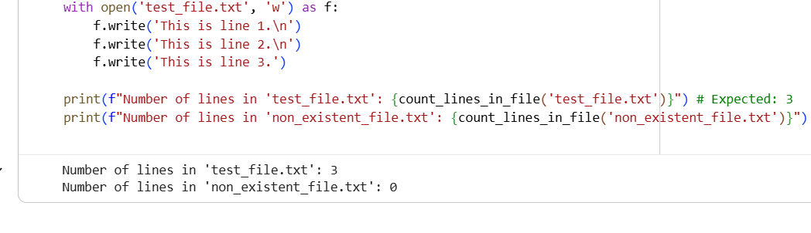

Conclusion
In this experiment, AI assisted coding using Zero-shot, One-shot and Few-shot prompting produced different levels of accuracy and completeness. Few‑shot prompting generated the best results consistently because examples guided the model. Zero‑shot was fast but not always accurate, and One‑shot worked better when at least one example was provided.

